In salesforce app is nothing but collection of tables

Remember
Isntead of writing logic Always try to do it in db- like creating formula fields..

Features
It’s powered by metadata and made up of different parts, like low-code tools, workflow automation, artificial intelligence (AI), and robust APIs for development.
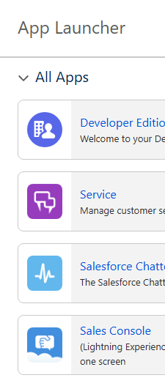 | here each app is nothing but collection of tables  1 app can contain many tables  object== table  2 types of objects- standard, custom,  objects are collection of various fields and tabs in salesforce  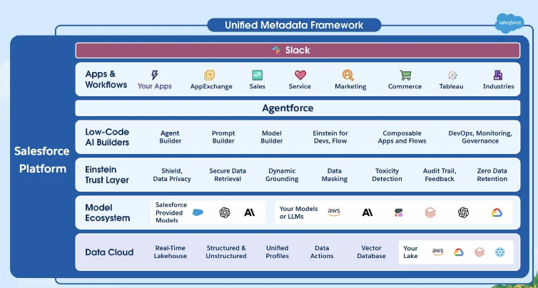
flow builder | every app on the platform can use tools like Flow Builder and Salesforce generative AI
prompt builder | Prompt Builder is a low-code AI builder that’s part of the Salesforce suite of generative AI tools  With Prompt Builder, D’Angelo can create custom AI prompts grounded in Dreamhouse and customer data that communicate with large language models (LLMs) to generate things like personalized emails or customer service replies. He creates a prompt template that generates customized emails about these new properties for potential buyers, based on the specific property preferences they’ve discussed with their Dreamhouse broker.
Data cloud | Data Cloud is a hyperscale data engine that is natively built into the Salesforce platform, and can be used all across it. It’s not a traditional database, but rather a data lakehouse.  Data Cloud enables teams to unlock data trapped in other warehouses or lakes,
to see all free apps by sf | https://appexchange.salesforce.com/  this is same like our playstore  Before installing any app - Develop a plan, including budget, timing, and key department use cases.
schema builder | you can see table relationships in visual way using  setup – home—schema builder  use schema builder to see objects and relationships with the help of pictorial relations,  like u can see all one to many relation ship between 2 tables  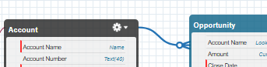  - Use Schema Builder to create a schema for a given object model.  - Use Schema Builder to add a custom object to your schema.  - Use Schema Builder to add a custom field to your schema.

Setup & tabs
comp info | setup—comp info
setup – users | u can see all users, u should map every user to certain profile,  u can create a user here ,  when we create a dev org- then we are having license named “salesforce user”
setup—profile | we need to assoc every user to a profile
setup—view setup audit trail
login history | user can every user when he logged in – from which ip ,location, browser
to create ur own domain | setup – home – my domain – after creating domain – just deploy  mmna-dev-ed.develop.my.salesforce.com
installed apps | to see all the apps u installed in ur org ,  goto setup – installed packages  - From Setup, search and select Installed Packages in the Quick Find box.  - Click the name of the package you installed. It will be the same name from the AppExchange download page.  - Click View Components to see more information about the package. The Package Details page shows you all the components, including custom fields, custom objects, and Apex classes in the package. This information helps you determine whether you have any conflicts in your own customizations.

Objects

Object == table in salesforce, in object manager u can see all objects , every object could belong to one app in sf
Every obj will have ID col= 18digit – sometimes we might see 15 digit id ,but api returns us 18 digit id (when u export the data u will see this id)
We will add a field called record owner – to ensure who can see the record
Default objects- opportunity (Deal)

Each object can have:  - Fields (data columns)- some will be default /standard columns given by sales force  - Relationships (links to other objects, e.g., Lookup, Master-Detail)  - Page Layouts (how the fields appear)  Record Types (different layouts for different business scenarios) | to create new field  goto object – fields and relationships – new  to create few more fields—click save and new

Create objs and Tabs
A Tab is like a shortcut or a window that lets users access an object’s data through the Salesforce UI.
Think of it as:
The front-end representation of a back-end object.
When you click on a tab in Salesforce (like Accounts or Leads), you see all records and can create new ones.
how to create objects in salesforce
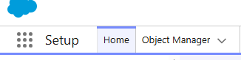
setup—obj manager – create
creating a table in salesforce

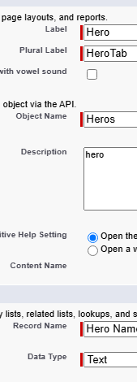  - here plural label means – tab name  - obj name== table name | - Click the Object Manager tab.  - Click Create | Custom Object in the top-right corner.  - For Label, enter PropertyCopy. Notice that the Object Name and Record Name fields auto-fill.  - For Plural Label, enter PropertiesCopy.  - Prior to saving the custom object, scroll to the bottom of the page and select the checkbox Launch New Custom Tab Wizard after saving this custom object.  when u create a table – by default 3 columns will come automatially  - ID which is primary key , Name ,createdby, lastmodified date and time  obj name== table name  2) check this to create a tab  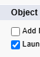  Launch New Custom Tab Wizard after saving this custom object  3) assoc ur table to certain app  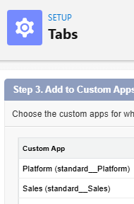  after creating that obj u can see that obj in sales app  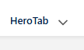
 | You can customize standard objects by adding custom fields, and you can add custom fields to your custom objects.

Object Relationships
While creating a field ,we can select the relationship (objfields & relationship—choose either lookup or master detail relationship—choose child table)
Salesforce Concept | Meaning
Lookup Relationship | Two classes know each other, but can live independently.
Master-Detail Relationship | Child object cannot exist without parent object.

Note all extra columns will be in child table only to refer parent col
lookup relationship – parent child  when there is loose relationship prefer this – college – university  ex1:-a college can exist without university bec some colleges will be autonomous  house real estate- offer , contact can live independently , sometimes to just tract to whom we gave offer we can link those tables in lookup relationship  use case- if 2 obj can live independenly then choose this  so for loosely coupled tables prefer lookup relationship  Dependency Child record can exist without the parent.  Cascade Delete If parent is deleted → child stays (relationship field becomes null).  Ownership Child record has its own owner and security.  usecase- When records are related but if they can stay independent without each other then choose lookup realtionship (e.g., Contact ↔ Account, or Student ↔ Teacher).  while creating a field select this lookup relationship option  Objects in lookup relationships usually work as stand-alone objects and have their own tabs in the user interface.  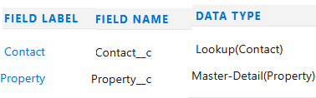  when we create lookup relationship , child table col will contain parent table row ref  opp (child table), acc (parent table ref)  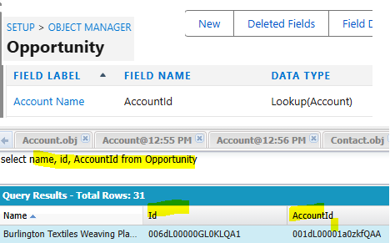  here a new col (accountId) is created in child table stores the parent row ref ,  this is like storing parent table foreign key ref in child  1 table can have lot of lookup relationships with other tables (below case table col are having lookup rela with many other tables)  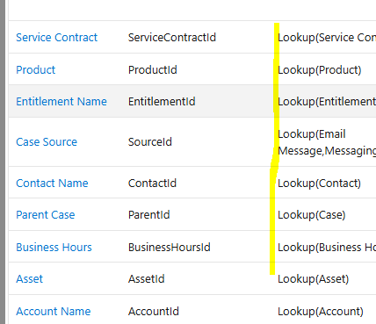 | master detail relationship – here new field will be created on child table to refer parent table (master-detail relationships are a bit tighter. In this type of relationship, one object is the master/parent and another is the detail/child.)  ------  when there is a tight relationship between 2 tables then choose this like  like student and dept, bec every student must belong to dept – since student cant exist without dept for those tight relationship cases choose master detail relationship  If parent is deleted → all related child records are deleted automatically.  ex:- if dept is deleted – then delete all students in that dept  relationship field will be on child table- which will help to query master record  while creating child u should link the parent id  steps to create  obj – fields – master detail relationship

steps to create a relationship

goto child table a create a lookup column (bec child needs to store the ref of parent row)  book(child) , author (parent) 1 author will have lot of books like 1 parent can have multiple childs  fields & relationships -- > new – lookup relationship –select to which table this should be linked-  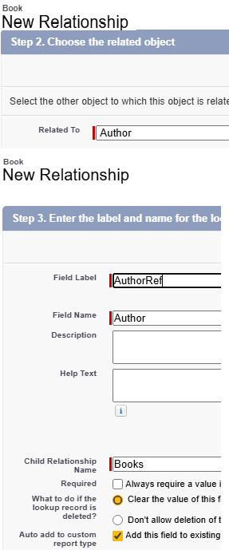 | 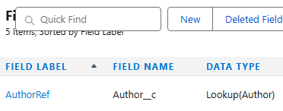  select id, name, Author__c from book__c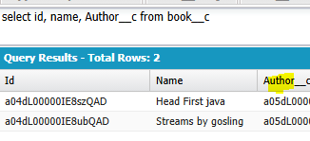  then a new field named author__c will be created which stores the ref to parent table  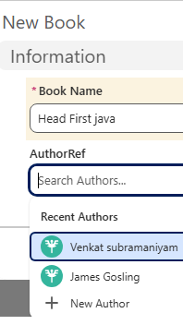  then while creating new book we should link author

Column/Field types And organize fields under a section
Obj—fields & Relationship – create a new field
Formula field:- create a formula field  ex formula – TODAY() - DATEVALUE(CreatedDate ) // No of days  in above createdDate is a col name- which gives date & time, DateValue() is a function converts date time to date, TODAY() is the default function available to us  while creating a column – choose the field data types as this  $User, $Organization are 2 global variables  advanced formulaa--click insert field to choose existing field  ex: use cases-  we created this formula field in lead table – days open  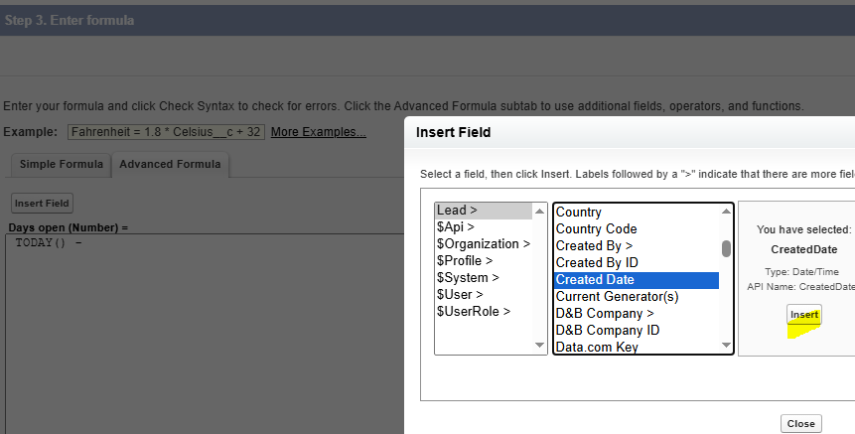 | Rollup summary –This is a read only field which contains info of child records for that master record (count, min, max, sum)  hence the new field will be on parent table  1 parent can have many childs  - so go to master table and add the field – rollup summary  in summarized object- select the child table  rollup type – count …  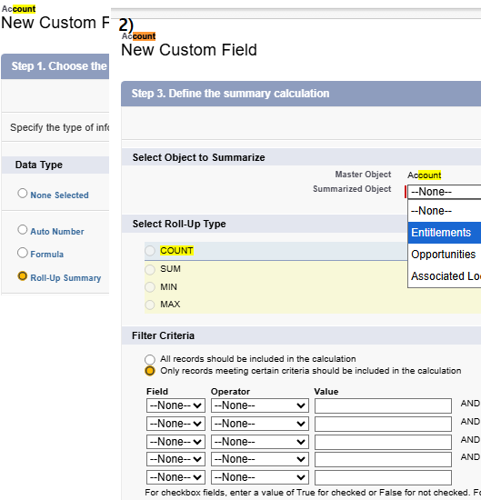  note :- while creating rollup summary column, both tables must be in master details relationship only- not just lookup relationship

creating sections in layout and add fields to a section (we can customize – where to put each fields)
Text Col types– Text (255 in single line), Text Area (255 in sep lines),
Text Area(Long-more than 255 char), Text Area (Rich- means we can write in styles& add images)
ex:- create fields in acc object
field names- Acc Text…
instead of defaulty adding fields to some section , u can customize like this
creating sections in layout and add fields to a section (we can customize – where to put each fields)  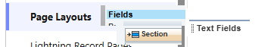  select proper layout- I selected acc layout – not sales/marketing..  under object—Page layout –create & Add a section – then we can add 4 new fields to this section  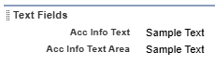  after adding fields will look as | 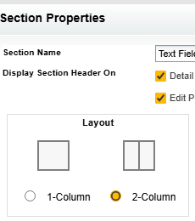 | after adding –if u open acc tab,  all our 4 fields will appear under text fields section  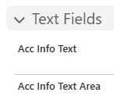 | Read only fields  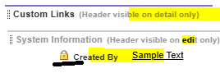  in page layout—section- for that field if lock symbol is present it means- we cant edit that field  - while adding a field to a section, make sure section is editable

Based on the way u organise fields in section , they will appear in similar order
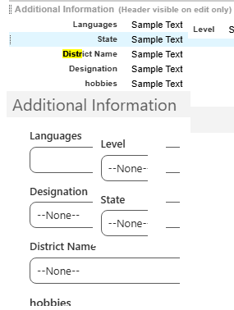

Picklist(radio button- means select only 1 ), picklist Multi Select –  - add these 2 new fields designation (CEO,CFO,Mana,Qa,Dev), hobbies to contact obj- add info section –  Dependent picklist  ex:- if we select andhra then show andhra states, if we select TN, then show TN state names  while creating field- field dependencies – there we can select which field is dep on which field  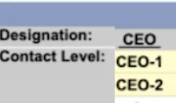 keep these 2 fields in same section select the mapping- - after clicking data for each select include values this means when we select CEO , then only CEO-1, CEO-2 will be visible Here controlling field is designation, - means based on this field selection dep field will change dependent field is – contact level- means this field is dependent on controlling field | while creating picklist,  we can even create a global value set (weekdat, Months)  home search for picklist value sets  then while creating a picklist – we can use global picklist  Advantage is we can re-use the same data set if we are using in multiple tables  task- try to create a global value set – and associate that with pick list & with picklist MultiSet
while selecting mapping
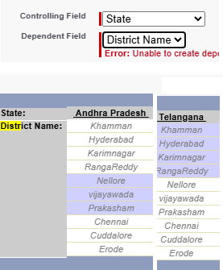 | for each state select dis names  ex:- here for andhra I selected nellore, vijayawada..  select include values  now- when we change statename, district dropdown values will change automatically

Data loading
Data loader.io – loader max 10,000 per month in free
To delete mistakenly imported data- home --mass delete rec
Before importing- clean up ur data by removing duplicates.., add a col for record owner,parent record
after importing sensitivity data, apply visibility settings like roles, profiles..
- see salesforce field ref guide
Data loading  while importing 1st import parent table, then import child table  - export all – will export data in recycle bin also  - always do a test batch of 4 rec  - if success import full file by execluding those 4 rec  - turnoff workflows /triggers during export else it will mail | - Data Import Wizard—this tool, accessible through the Setup menu, lets you import data in common standard objects, such as contacts, leads, accounts, as well as data in custom objects. It can import up to 50,000 records at a time. It provides a simple interface to specify the configuration parameters, data sources, and the field mappings that map the field names in your import file with the field names in Salesforce. Use the Data Import Wizard When: - You need to load less than 50,000 records. - The objects you need to import are supported by the wizard. - You don’t need the import process to be automated. - It will catch dup based on name and email - Cant export procedure home—data import wizard after importing to see status enter “Bulk Data Load Jobs” in the Quick Find box, then select Bulk Data Load Jobs - Data Loader—this is a client application that can import up to 150 million records at a time, of any data type, either from files or a database connection. It can be operated either through the user interface or the command line. In the latter case, you need to specify data sources, field mappings, and other parameters via configuration files. This makes it possible to automate the import process, using API calls. Use Data Loader When: - You need to load 50,000 to 150 million records. If you need to load more than 150 million records, we recommend you work with a Salesforce partner or visit the AppExchange for a suitable partner product. - You need to load into an object that is not supported by the Data Import Wizard. - You want to schedule regular data loads, such as nightly imports. - It will catch dup based on ID only, hence this field is mandatory - It can export data - Data loader recognizes one field for the address (if u have 2 addrs 1,2 u should combine beofre importing)

Data export
- Data Export Service—an in-browser service, accessible through the Setup menu. It allows you to export data manually once every 7 days (for weekly export) or 29 days (for monthly export). You can also export data automatically at weekly or monthly intervals. Weekly exports are available in Enterprise, Performance, and Unlimited Editions. In Professional Edition and Developer Edition, you can generate backup files only every 29 days, or automatically at monthly intervals only.  setup -- export | - Data Loader—a client application that you must install separately. It can be operated either through the user interface or the command line. The latter option is useful if you want to automate the export process, or use APIs to integrate with another system.

Create Custom Apps
Setting app manager—create ur new app
A Lightning App in Salesforce is basically a custom workspace built for a specific job function or user group.
It bundles together the objects, tabs, and tools people use most often into one easy-to-navigate place inside the Lightning Experience.
while creating app
add utility items – einstein next , chatter feed (can be seen in bottom left)
add navigation items (tabs)—acc, contacts, properties
profile – sys admin
console navigation
in standard navigation—new data will be overridden current tab
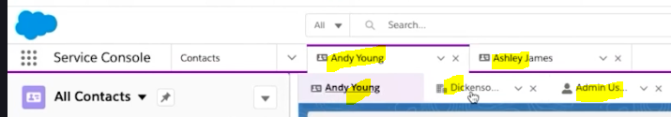
these are best apps – in console navigation same tab we can open all subtabs and child tables – benift is it will not override the page- instead new data will be in new tab

so while creating app – choose style- either standard navigation or console navigation

Misc features

Page layout vs compact layout

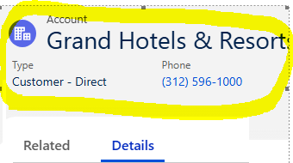 | here page layout == details tab (When we open details tab on any object- what we see is page layout)  compact layout == layout above 2 tabs (related, details) there is some info like type, phone  those are compact tab  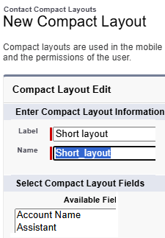 - create a compact layout and - choose ur layout 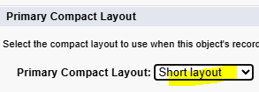 to see all existing page layouts for that table 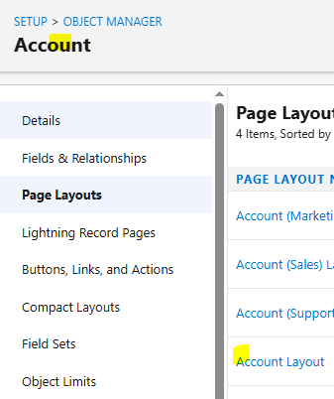 here in this u can drag and drop all layouts

page layout | here we will add a section called (Account history) to page layout (goto obj—page layout—select a layout)
configure page layout  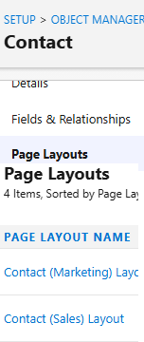 | create compact layout under – obj—compact layout (max allowed fields in compact layout is 10)  - Create a compact layout and map that newly created compact layout as default  a compact layout can only contain fields from its object,  Compact layout support allfields except test are, long text area ,rich text,  in salesforce, a field set is a group of fields that can be added to a visual force page  Each record type can have only one compact layout assigned to it. However, the same compact layout can be associated with multiple record types.  A compact layout can only contain fields from its object, including a formula field that is a cross-object reference to another object.

Feed tracking (tracking few fields)
For audit purpose if u want to see all the old and new values for a record and field and to see who changed that record .. all will appear in history
In java we will use javers or envers or we can use triggers so that if any account updated we should manually insert that old and new values in separate audit table to maintain the history of what and who changed it
I like this much – because if we want to create the same in java we should write AOP’s , javers, envers..we should create separate table and we should manually insert all those audits in that new table

To track all the (Feed tracking )  Home—feed tracking – select table name – fields to track (so that if someone updates the value then u will see the old & new values are history)  Note:- all d updates made to that record can be seen in In chatter ,  all real time modification on that table can be seen in chatter feed  max 20 fields can be set to track | activity/updates will come in feed  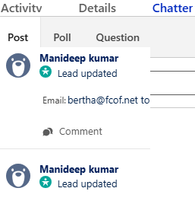 | after updating email field , since we are tracking that field, any changes to email will update here  - We should configure here to track those fields  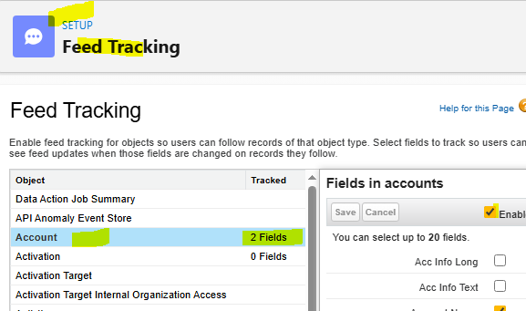

Only diff between feed tracking and history tracking is – In history tracking all the history will be displayed in tabular format

Feed history tracking  To track all field that is present in  Goto table—fields and relation ship—set history tracking – Enable account history -- select all the fields u want to track  - Select all the fields to be tracked  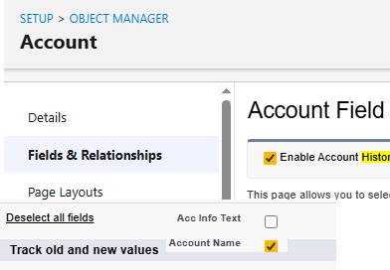  here select all the fields u wanted to track | step 2- we should configure where  to display this history table  (which contains changes made to tracked rec)  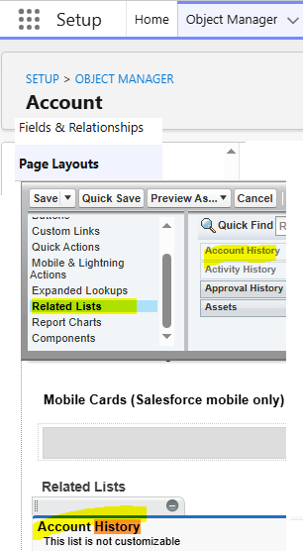 | now if u change the tracked fields it will be shown in the table with old and new values  here in this scenario, all the history will be under “Account history” section  in page layouts, I kept account history under “related list” section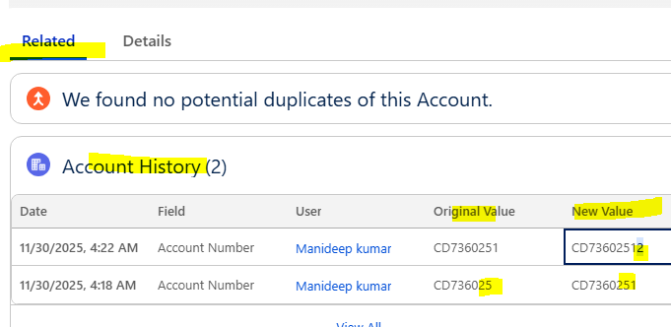

List view in sf
All these lists will be appeared in obj tab, we are creating separate view to
  - customize the existing view by adding or removing few columns
  - filter few records by applying some conditions
we can see these lists in account /any obj dropdown  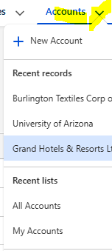 | - to create a new list & select the fields/cols to display  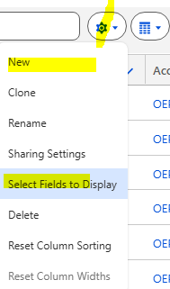  after creating list u can customize which columns to display | filter out few records from result set  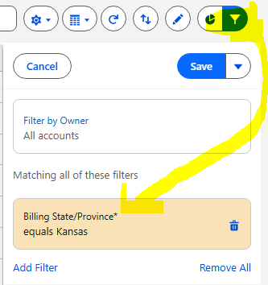  if u add a filter its like where clause- so that many records will be filtered out | write more filter and use AND , or OR condition by applying all those filters  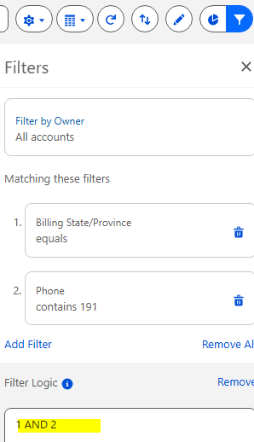

Applying validation rules In sf while saving records in db
https://help.salesforce.com/s/articleView?id=platform.fields_useful_validation_formulas_account_address.htm&type=5
we can apply Not null constraint on column,
but when we want to create a rule like revenue must not be <200CR .. and name must have more than 2 characters in this case we should write custom validation rules
so all these validations will be executed when we are saving or updating a record
Create a validation rule on the object manager (Obj – validation rule- create a rule like ex:- ISBLANK(annualRevenue) )
All this validations will be executed when we save / update a record
AND | OR
AND(  OR(BillingCountry = "CAN", BillingCountry = "CA", BillingCountry = "Canada"),  NOT(REGEX(BillingPostalCode, "((?i)[ABCEGHJKLMNPRSTVXY]\\d[A-Z]?\\s?\\d[A-Z]\\d)?"))  ) | AND (  OR(BillingCountry = "CA", BillingCountry="CAN"),  OR(  LEN(BillingState) < 2,  NOT(  CONTAINS("AB:BC:MB:NB:NL:NT:NS:NU:ON:PC:QC:SK:YT", BillingState)  )))
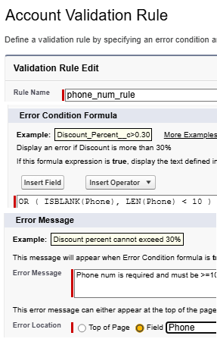
OR ( ISBLANK(Phone), LEN(Phone) < 10 )
means when phone num is blank or when length <10 error will be thrown
means if this condition is satisfied then this error message will be shown
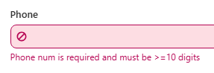
so while saving record, if we didn’t give phone num , then error will be thrown as above

Record types & page layouts
, a Salesforce user, wants different fields in one page layout.- go and edit the page layout (obj – page layout)
Salesforce user, wants different fields in one page layout. How can he control these two page layouts? – by creating 2 separate rec types

Farry, a Salesforce user, has selected a picklist value for a record type. How can he control what picklist value is available for which record type?

what is page layout ?-  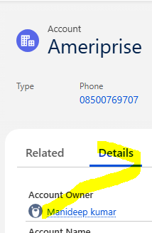  in any table records like accounts tab - on any record when u click details tab, u will see all details in some layout that is callled the page layout  u can customize that page layout (means customizing that details tab)  why we are creating another layout – just to customize details page by adding or by removing the fields  path to create new layout(obj—page layouts--New)  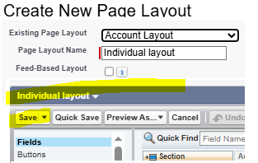 after customizing page layout save 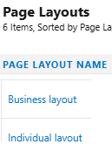 see all layouts here after creating layout u need to configure to few record types  Note:- creating a page layout(by hiding and organizing the fields ) is not enough u should configure that layout to a particuar record – by creating record type  ex:- for 1 table – we can create multiple layouts, so when we open details tab sf should know right which layout it should use to display the details – hence we should the configure that layouts to particular records | u can see all existing record types In object—record types  - through record types- we can control picklist values for editing  creating a new record type and assign that to some layout  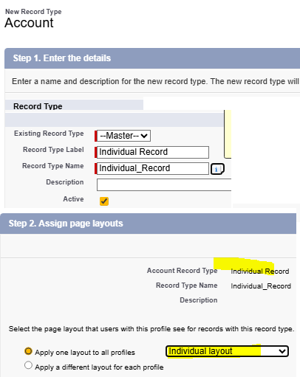  its like we are telling for individual type of record use individual layout to display & to create  ex:- for record type-C , use type-c layout  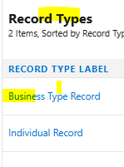 for each rec type we can configure sep pick list now after creating 2 record types, everytime it will ask us before we insert a record 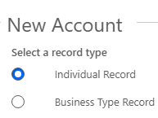 now for individual record edit page and display page are different from business type rec  see the layouts are diff for each record type
edit layout for individual rec (2 colmns as per layout configuration)  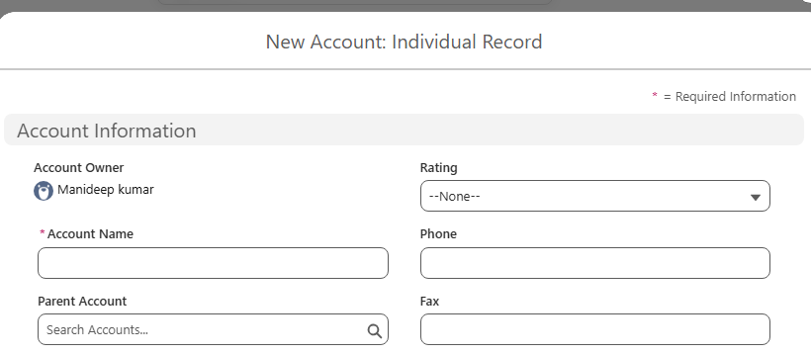 | edit layout for business record (only 1 col as we configured 1 col in our layout)  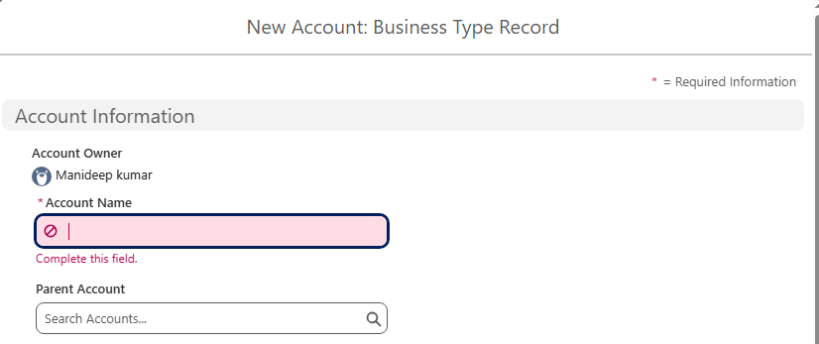

Even if u create multiple page layouts (obj—page layouts) u again have to create record types (under object – record types)

Email templates and alerts

Folder is where our template will be stored
Here {!contact.firstName} is called merge fields

To see all existing templates --Home—email—class email templates  Creating a template  Home—email—classic email templates – new template  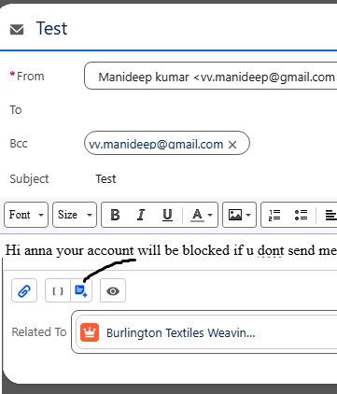  here u can select the template while sending email manually | - create a template,  - use that template and create an alert  - configure that alert in flows- then only alerts will be sent automatically  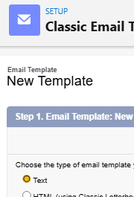 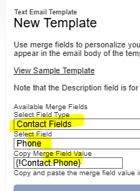 here contact field is table name 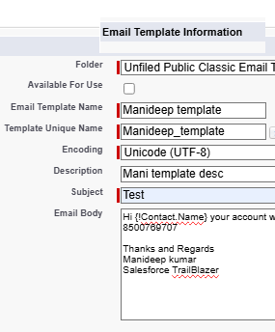 here we used merge field in email body  While creating a text email template we don’t need to do any coding- for remaining we need to do coding
sending mail manually | sending mails automatically

sending automatically (here we are creating an email alert) that email alert will be used by a flow 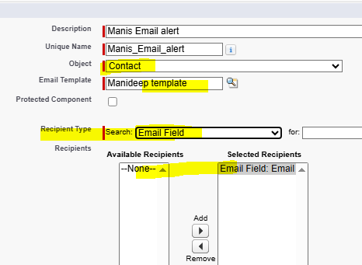  here we should select the email template also  in search box- we can see only those fields available on object  template- it contains only what content to send  alert- it defines whom to send the alert | home—email alerts  after creating email altert, you should configure this alert in workflow rules or process builder or flows  then emails will be sent automatically  1)choosing obj name:-  In Salesforce Email Alerts, the Object you select must match the object from which the email alert will be triggered.  we selected Contact → that means:  - Your email alert can be used only in:  ✓ Workflow Rule on Contact  ✓ Process Builder on Contact  ✓ Approval Process on Contact  ✓ Record-Triggered Flow for Contact  Otherwise it will not appear.  Why must the object match?  Because Salesforce needs to know:  - Which record is sending the email  - Which field values are used inside the email template  - Which merge fields (like {!Contact.Name} or {!Opportunity.Amount}) are available  If the object is wrong → the email alert will not show in workflow/process selection.  Rule: Select the SAME Object as your Workflow / Process / Flow Trigger  For example:  Where Email Alert is used Which Object to select?  Workflow Rule on Contact Select Contact  Workflow Rule on Case Select Case  Process Builder triggered by Opportunity Select Opportunity  Flow that runs for Lead Select Lead  Approval Process on Account Select Account  There is a simple rule: Always create the Email Alert after deciding which object will trigger the automation.

Managing activities in salesforce & actions
- Creating a task | 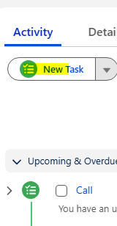 | here in oppor table went to activity and created a task (in backend a record in task table will be created automatically)  Task: "Call customer to understand requirements"  Useful when:  - sales team must always make an initial call  - company follows a fixed sales process  Real-World Example  You’re selling software.  Opportunity stage = Proposal Sent.  You automatically create a task:  Subject: Follow up regarding proposal  Due Date: Today + 2 days  Assigned To: Opportunity Owner
displaying activity tab | 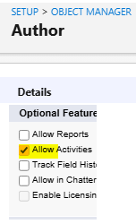 | for default/standard obj this activity tab will be checked automatically  for custom obj we have to manually enable to from details page- else we cant see the activity tab itself
creating a global action  - u should create action &  - publish that action |  | 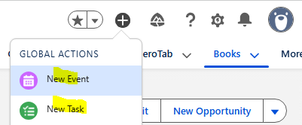  - to see existing global actions – click +  home—global actions- new global action  after creating a global action- we should goto home -- publisher layouts – add our action to the global layout  publisher layout—mobile and lightning actions—search for our new action name – add it to sf mobile & lightning actions  advantage is – if u create a global action – directly record will be created (alternatively we can go to that object and do manually also)

